# Initial Design Ideas

## Rule View Activity

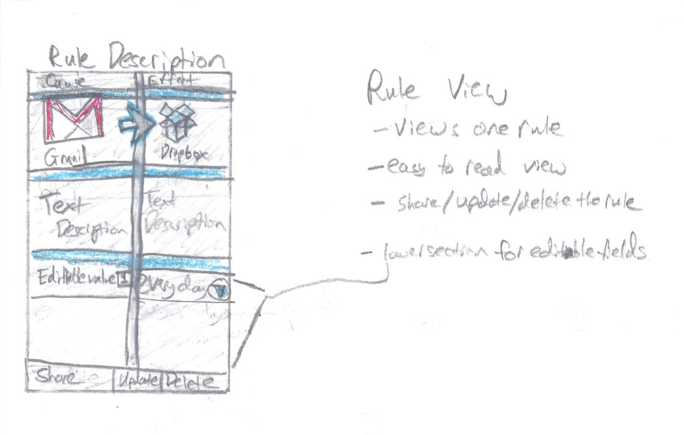

* Here, the user will follow the rule description page as they create the rule. They click on the cause size to choose a cause, and the effect page to choose an effect. As the user adds causes and effects, they will return to this page to see how their rule has progressed as they create it.

## Drag and Drop View

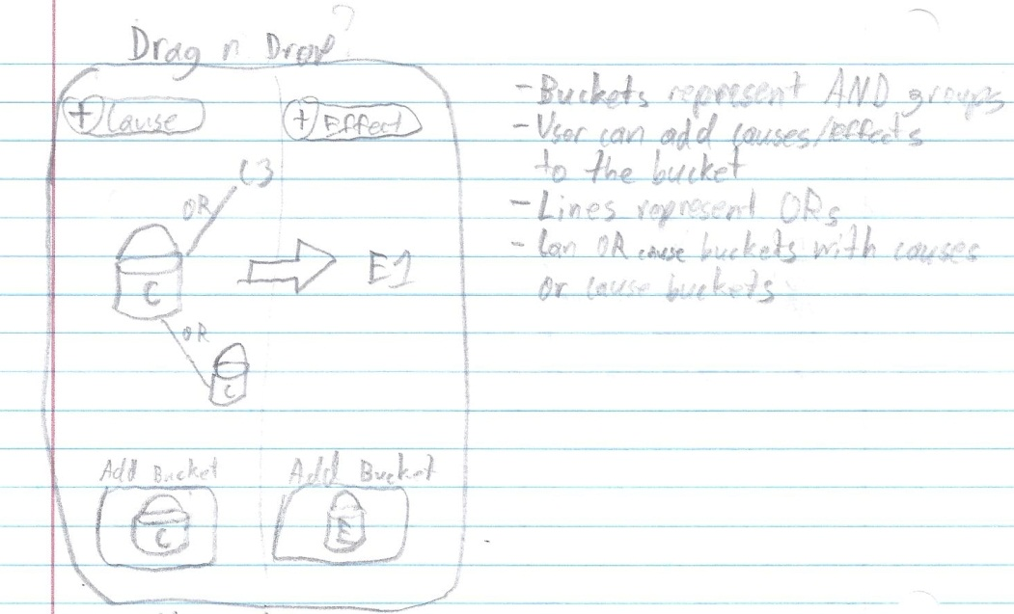

* Here is an idea for a drag and drop implementation of the rule creation page, in which users place selections in “buckets” to represent groups of causes or effects, and link them to other buckets or individual items by an OR line. This would create a more abstract view for rule creation and could benefit visual-based users.

## Rule Creation Activity

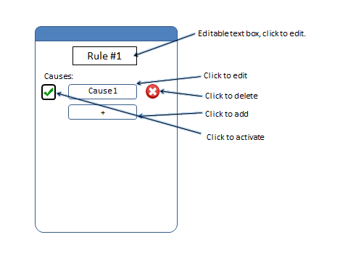

* Here is a rule creation page in which causes and effects are separated by different pages and takes a more list view approach.

## My Rules Activity (Version 2)

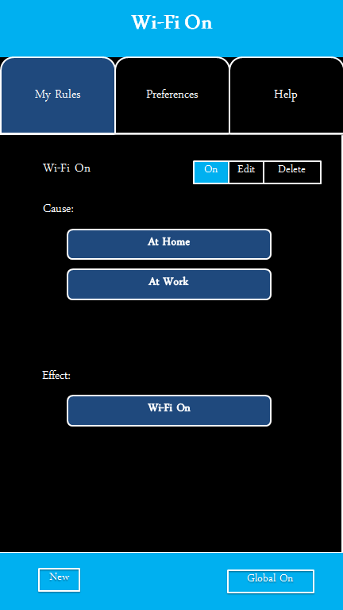

* Another conceptual rule view where causes and effects are listed sequentially in a list format.

## Account Sync Activity

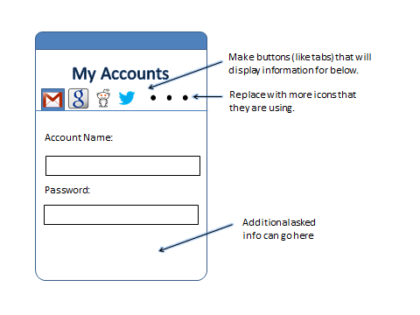

* This is an accounts page in which the user syncs their Google, Facebook, etc. accounts for use with rule creation. Another idea was moving the list of accounts to a separate page accessed from preferences, rather than a slide at the top.

## My Rules Activity

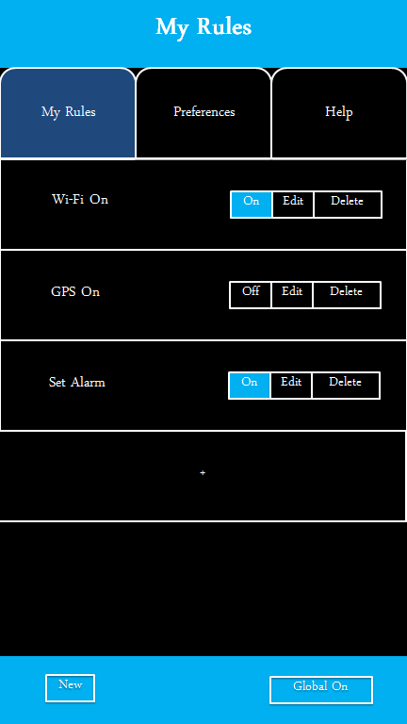

* This was a concept screen for the viewing of existing rules. From this screen, users can turn a rule on or off, go to the edit menu, or delete the rule.

## Help Activity

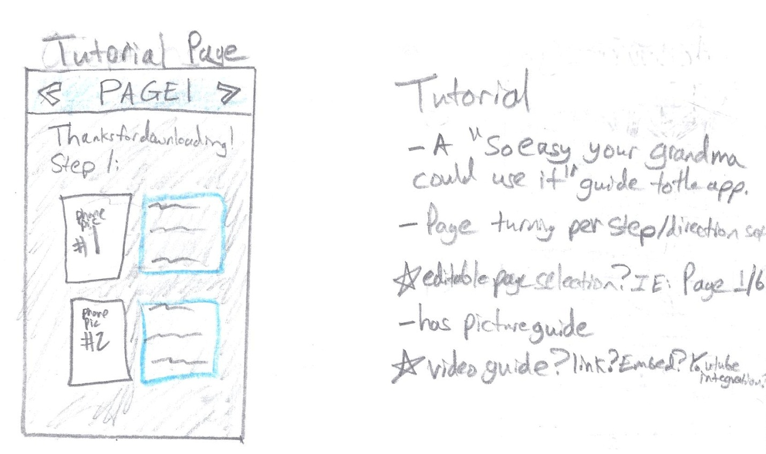

* The tutorial page is an idea we had that would help first time users understand how to operate the app. There was also an idea for a tutorial overlay for the app that would direct users towards options and functions for app operation.

## Image (8)Android Screen Flow Diagram

* This flow diagram represents the expected usage and screen flow for users operating the app.

## Rule Handling Workflow (Backend)



* This flow diagram represents the initial backend design for the app.